Methodology

Foreign Investment Survey 2014

Table of Contents
1: General Background of the Survey | 3-4
2: Comprehensiveness of the Survey | 4
3: Stages of the survey | 5-9
4: Survey Key Documents | 10
5: Survey Staff | 10-13
Main Definitions | 12-14

1: General Background of the Survey
1.1 Introduction
Since its establishment, Dubai Statistics Center (DSC) is keen to provide the necessary statistical, social, economic and demographic data for decision makers, policy makers and those who are interested in various forms of studies. DSC strives to keep pace with the rapid and continuous development in the field of studies through developing its technical and technological capabilities to achieve a high level in its field to compete with the statistical agencies in many developed countries.
Foreign investment is one of the vital topics in which countries are interested because of its important role in the economic development process and economy income resources diversification in different fields. Foreign investments increase production capacity and raise economic growth rates. Foreign investments play a role in the transfer of the latest technology, methods of knowledge, creating more job opportunities, and achieving integration among the economic sectors which help achieving sustainable development.
Given the importance of foreign investment in economic development, DSC was keen to conduct foreign investment surveys for economic establishments which have foreign investments according to the approved international standard. This survey comes within the framework of creating an updated, accurate, and comprehensive database to assist policy makers and decision makers in identifying the position of foreign investment in the Emirate of Dubai. In addition to that foreign investment survey carried out in coordination between statistical centers in the UAE to get to the data on foreign investment at the state level without duplication, therefore we set a conditions to control and achieve the goal.
2.1 Survey Goals
The main goals of the survey are to provide data reflecting on the position of the foreign investment in Dubai- based on institutions and their distribution by economic activity and by countries from which such investment is flowed. The Foreign Investment survey is the milestone in the international investment position preparation, in addition to the fact that the survey is a main source of the financial account data in the balance of payments.
Generally, the foreign investment survey aims to:
- Providing UAE decision makers with updated and accurate data about the size of foreign investment in the country.
- Determining the size of foreign investment in the Emirate of Dubai.
- Identifying the economic sectors and activities which received the foreign investment.
- Identifying the countries of foreign investment.
2: Comprehensiveness of the Survey
All establishments with foreign direct investment (FDI) and establishments with portfolio investments listed in Dubai Financial Market, in addition to the establishments with other investments having overseas transactions in the form of loans, investments, or others, were identified based on the most recent statistical. Establishments were comprehensively identified and the study included those licensed by Department of Economic Development as well as those licensed by the Free Zones.
3: Survey Key Documents
Survey documents included questionnaires and instruction manuals for supervisors, researchers, manual and electronic audit tools. Below is a summary of the key documents:
3.1 Survey Questionnaire
3.2 Instruction Manual
The instruction manual includes all definitions and concepts used in the survey and the detailed instructions for the field staff at their different supervisory and executive levels. It also includes a detailed explanation of all questions and concepts included in the questionnaire’s different sections and classifications used for each, in addition to how to fill in the data in a manner that ensures the data being obtained with the highest possible degree of correctness and accuracy. The manual also included the basic audit rules for the staff across all levels to follow during auditing with focus on the completion and the logical relations between the answers and guidelines to detect and correct errors.
4: Survey Staff
4.1 Survey Staff Functional Structure
Staff who participated in the technical, administrative, and fieldwork of the survey was organized as follows:
- Survey General Technical Supervisor: The most prominent duties of this role are preparing all technical approaches related to the survey "integrated approach, audit approach, results extract approach…" He is also the only reference for any technical instructions related to the survey questions, concepts, definitions, and variables and any other technical aspects and matters related. Moreover, he is responsible for training of the staff participating in the survey, testing and preparing a detailed report of the survey's key deliverables and forwarding it to the technical administration in charge of the survey.
- Survey General Field Supervisor: The role’s responsibility is to monitor all survey field matters, and provide the survey team with reports on the progress.
- Administrative Supervisor: Manages and executes the field operations, provides the general supervisor with periodical reports about the progress.
- Programmer: The most prominent duties of the role are to design a program for the questionnaire’s entry. Serves as a liaison between the researchers and technicians through monitoring the fieldwork, solving all problems related to the program, and sending the complete questionnaire data periodically, preparing the main database for the survey.
- Field Supervisors: Duties include the distribution of the daily fieldwork to his team, being constantly present in the work area, attending some interviews, auditing the completed questionnaires, acknowledging the completion of the questionnaire, and comment on the wrong ones.
- Male/Female Researchers: The duties of the researcher include executing the process of data collection and making sure all data is filled in before leaving the establishment, auditing the data obtained in the field, and submitting to the supervisor the completion reports on a daily basis.
- Audit Supervisor: His most prominent duties include distributing the completed daily fieldwork between the audit team, following-up the completed questionnaires auditing process right away, acknowledging that the questionnaire is complete, and providing the field supervisors with comments on the wrong ones.
- Auditors: Their duty is to audit the questionnaires at the electronic and office levels through the program in place, where all questionnaires that need corrections are monitored with the administrative supervisor.
4.2 Researchers Selection and Training
4.2.1 Field Researchers Selection
The staff was selected at their different supervisory and executive levels based on several basics including the previous experience in the field of censuses, statistical surveys and studies, knowledge of geographical areas and the use of maps, academic qualification where most of the staff were bachelor holders, in addition to the proficiency in English language and any other languages.
4.2.2 Field Researchers Training and Testing
Training of the field researchers is one the most significant stages in any field survey; so the fieldwork team was trained on the most important concepts and terms related to the foreign investment survey. The team was trained on the mechanism of completing the questionnaire and filling in the tables thereon. The training aims at informing the researchers about the foreign investment; identifying the survey goals; understanding the questionnaire contents and how to fill it out; in addition to the method of data request, audit, and review; informing the researcher about all instructions and recommendations to realize the desired goals of the survey. They shall be informed about the compliance with the following:
- The transactions must be registered based on the accrual principle.
- The financial statement must be obtained attached with the fully completed questionnaire.
- The values registered in the questionnaire must be in UAE dirham.
- Full compliance with instructions and guidelines given by the technical officer through the fieldwork officer.
The training also included the methods of conducting interviews and its privacy and how to deal with the establishment and overcome difficulties. Moreover, several office and field practical applications have been launched regarding filling out the questionnaire and the errors that appear as a result of such applications. The staff was trained on data office preparation processes, auditing rules, and how to detect the errors and correct what can be corrected to ensure the answers consistency. It is noteworthy that by the end of the training course a test was made on all survey staff at their different supervisory and executive levels. The test served a significant basis of survey staff selection.
5: Fieldwork Stage:
This part includes a brief presentation of the fieldwork stages which easily included fieldwork progress procedures and desk audit.
5.1 Organization of the Fieldwork
The fieldwork was organized and executed in a way that ensures that survey data is obtained easily and accurately. The work has been distributed to all sectors and planning areas in the Emirate. Field operations management was launched by the survey department headquarter. For the technical staff distribution to the work areas, it has relied on the size of work in the planning sectors and the degree of sampling locations spread and ease of contact and communication.
5.2 Data Collection Method
After the administrative supervisors, supervisors, and researchers were assigned, and distributed to the field teams and after the training course and pre-test were concluded, the field implementation stage started where these teams will visit the establishments to gather the information.
5.3 Field Audit
One of the most significant procedures adopted to ensure the quality of data and compliance with work are the regular field inspection visits by the supervision team to all field work teams in their locations. It has been confirmed that all completed questionnaires are audited at the work place by the supervisors. After coming back from the field, the supervisors and the supervision office were auditing a sample of the questionnaires in the main office especially during the first stage of the work. Daily audit program was allocated to each team.
In addition, the survey technical team was auditing a sample of the completed data and making all necessary notes. In case any errors are detected, the survey supervision office was usually circulating such errors to all supervisors and researchers on the next day to be avoided in the future. In cases when unexpected response is received from the field, these are studied by specialists to take an appropriate decision that will be thereafter circulated to all supervisors.
The purpose of these processes was to receive the highest possible accuracy of data and make sure that each question is completed as required.
6: Data Preparation Stage
6.1 Office Preparation
During data collection from the field, the desk audit team started to audit the data. The focus in this stage was particularly on auditing the consistency and completion of the data to minimize errors. Moreover, a specialized group of employees in DSC and survey was selected under the supervision of the survey technical team to conduct a final review of the audited data to reduce the size of the errors at a minimum.
6.2 Electronic Processing
The study programmer implemented the electronic processing and trained a group of auditors on how to use the questionnaire program which is prepared in advance for this purpose in the auditing process. The data was made available so that the automated instant audit can be performed through display screens, where the focus was on the completeness of data and whether the value is entered. It has been made certain that rules are implemented to ensure the data is consistent with each other and that it is logical as per other variables. Implementation of auditing rules and their effectiveness and the sequence of logical answers had a significant impact in ensuring the success of this process. After completion of preparing a file with error-free data, the preliminary results for all variables were extracted and studied by specialists in the survey technical team. Therefore, some direct rules were implemented on some questions and data was finally reviewed and accepted.
6.3 Results Presentation and Dissemination
Survey results were presented through Dubai Smart Statistics Suite available at DSC via the electronic statistics and statistical indicators systems. These deliverables are disseminated in several ways most important of which are:
- Electronically via DSC website.
- Dubai Smart Statistics Suite.
- Periodic press news which review the most prominent survey results.

The following table shows the number of the responses according to the source as the following:
Table of responses according to the source
Total | Administrative sources | Field survey
3708 | 2705 | 1003 | Number of responses

Main Definitions
Definitions and terms used in the survey questionnaire
The definitions and classifications used to survey the foreign investment were prepared based on the international criteria issued by UN and some of its specialized agencies. You can find below the key definitions used in the survey: 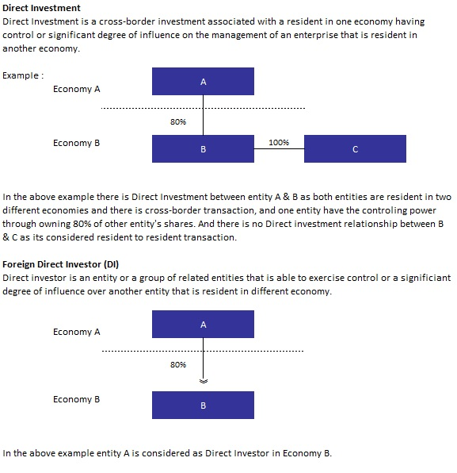
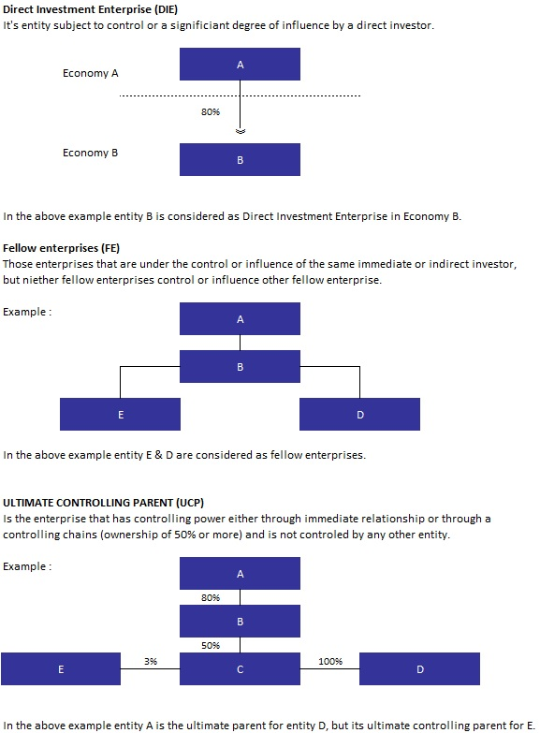

Portfolio Investments:
Portfolio Investments are defined as investments in tradable debt or equity securities between the entities that are resident in one economy and another entity that is resident in different economy.
Other Foreign Investments:
These investments reflect the foreign investments except for the portfolio investment or the foreign direct investment.
Main Economic Activity:
Main activity is the activity which contributes the most to the value added of the entity, it account for 50% or more of the achieved value added.
Resident in UAE:
UAE resident is any individual, establishment or other organization domiciled in the UAE or intending to stay for a minimum period of 1 year. Entities which are domiciled in UAE even if such entities are owned by foreign entities or nationalities are also considered as resident entities based on the principle of residence regardless of the nationality of their owners.
Non-resident:
A non-resident is any individual, establishment, or other organization that is resident outside UAE and or is intending to stay for a minimum period of 1 year. Entities that are located abroad even if they are owned by local entities are also classified as non-resident entities based on the principle of residence regardless of the nationality of their owners.

